Experiment 2: Vowel Detector

A submission Report

Hardik Dhansukhbhai Panchal

Roll Number 200070054

EE-214, WEL, IIT Bombay

August 19, 2021

## **Overview of the experiment:**

The purpose of this experiment was to get familiar with structural modelling concept used in VHDL codes. Means we have to instantiate components and use port map to connect those components.

We have to make a logic description of vowel detector. In that we have 16 alphabets and our code should identify the vowels and output 1 for that and 0 for other.

I have first made the DUT.vhdl file to take input and output data from TRACEFILE.txt and stored them as a vector. Modified the Testbench.vhdl according to need. Made K-map for this logic implementation and tried to minimise it and I succeed with making this whole implementation with only 4 gates.

My report has the RTL view of my design, the screenshots of RTL and Gate-Level simulations which contains their waveform window and transcript window. I have also specified the input and output format with MSB/LSB and wrote some test cases to elaborate. I have attached my DUT file code and main vowel detector file code also.

## **Approach to the experiment:**

## 

## **Design document and VHDL code if relevant:**

**Code of DUT.vhdl**

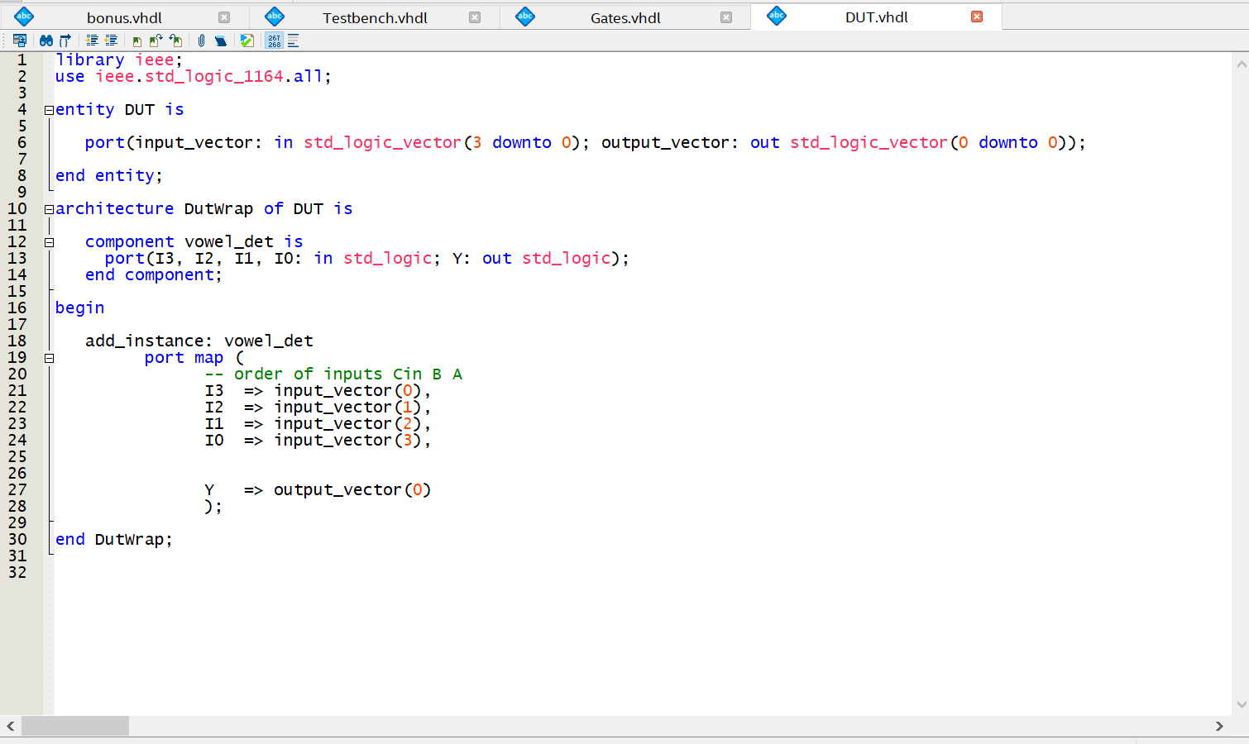

**Code of main file (bonus.vhdl)**

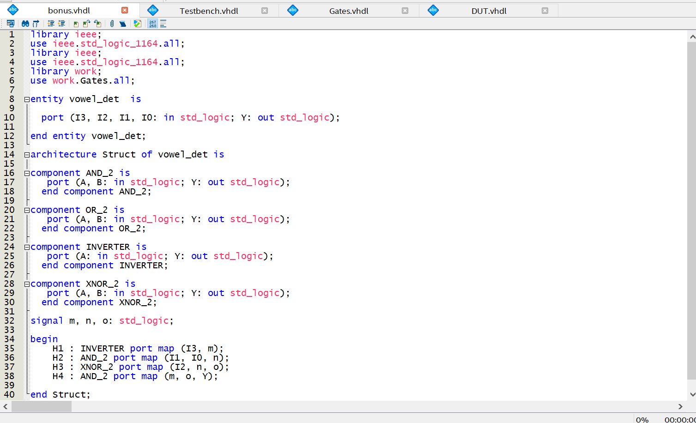

## **Design:**

## 

## RTL View:

## **DUT Input/Output Format:**

Input in TRACEFILE.txt has 4 bits. The first one MSB was x3, second x2, third x1 and fourth x0. Output has 1 bit. It is Y.

**Format of TRACEFILE.txt:**

<x3 x2 x1 x0> <Y> 1

**Test Cases:**

0000 1 1

0001 0 1

0010 0 1

0011 0 1

0100 1 1

0101 0 1

0110 0 1

0111 0 1

1000 1 1

1001 0 1

1010 0 1

1011 0 1

1100 0 1

1101 0 1

1110 1 1

1111 0 1

## **RTL Simulation:**

## **RTL Simulation_Waveform**

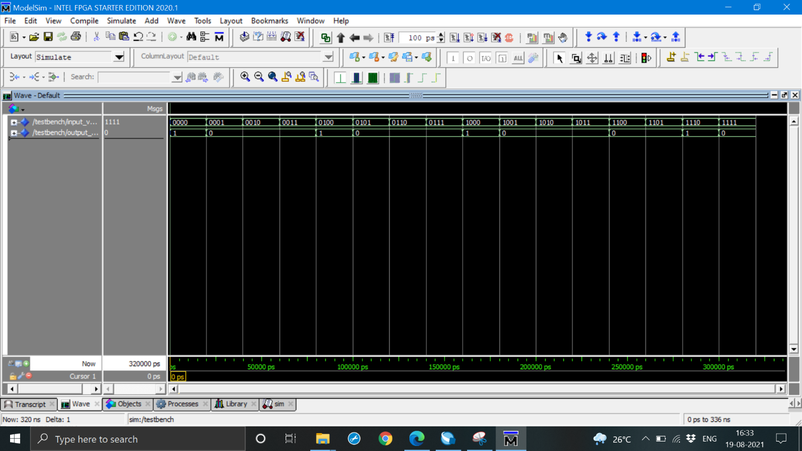

**RTL Simulation_Transcript**

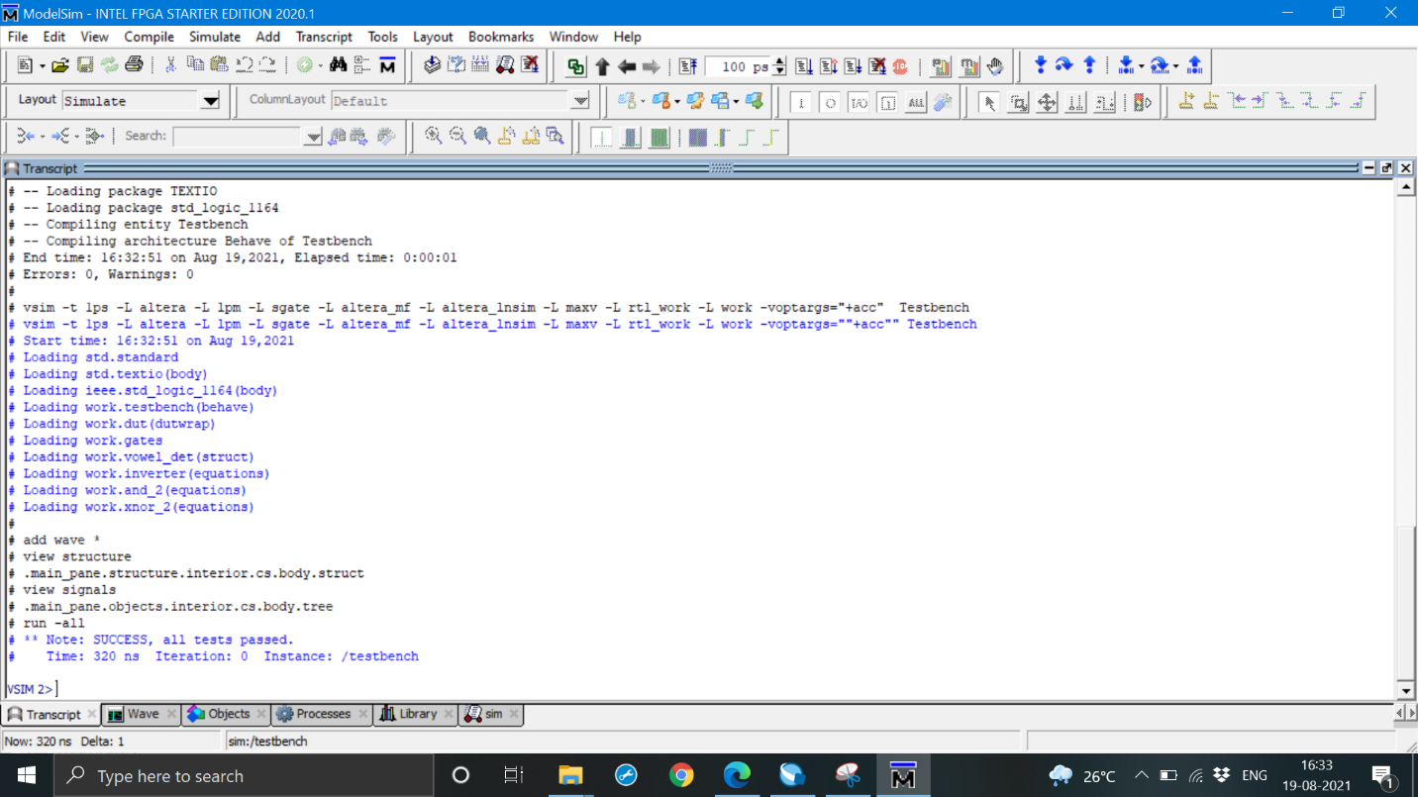

## **Gate-level Simulation:**

## **Gate Level Simulation_Waveform**

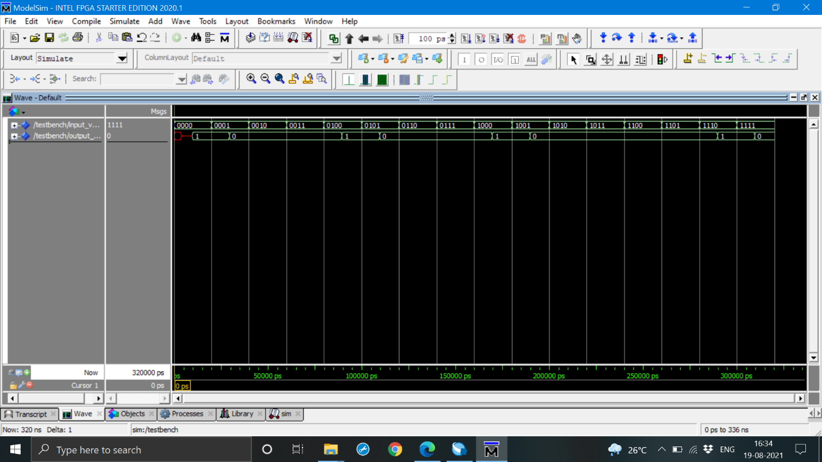

**Gate Level Simulation_Transcript**

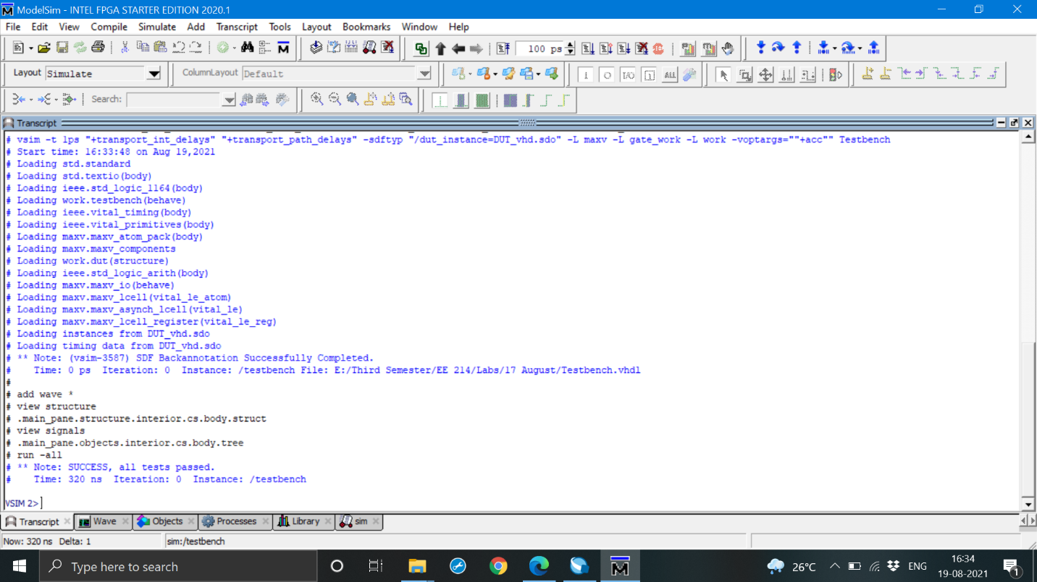

## Krypton board*:

|  |
| --- |
| Map the logic circuit to the Krypton board and attach the images of the pin assignment and output observed on the board (switches/LEDs). |

## Observations*:

|  |
| --- |
| You must summarize your observations, either in words, using figures and/or tables. |

## **References:**

As a reference to theory of K-map part I have used Prof. BGF’s slides of course EE 113, which he has taught us last year. It was very helpful to understand K-maps and their implementations. Prof. Dinesh Sharma’s VHDL slides were also useful as a reference to write VHDL codes.